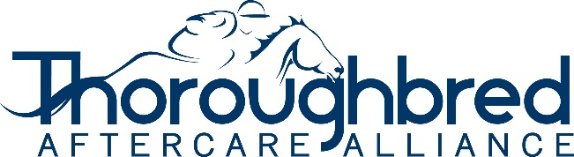

TAA Accredited Organization
2024 Quarterly Update Questionnaire

Organization Name:

Date:

Please answer the following questions and submit to the TAA with your quarterly update for:
(Circle one) January, April, July, and October

- Have there been any changes in your governance or board? ___Yes ___No
If yes, please explain (attach additional documents if needed)

- Do you have any new facilities since the prior update or application? ___Yes ___No
If yes, please list below and submit (1) facility form, (2) vet reference form, and (3) proof of ownership, foster, lease or boarding agreement.

Facility Name Facility Address

- Have you terminated agreements with or otherwise removed horses from any facilities since the prior update or application? ___Yes ___No
If yes, please explain (attach additional documents if needed)

- Have you had any issues arise or had any changes in situation that the TAA should be aware of since the prior update or application? ___Yes ___No
If yes, please explain (attach additional documents if needed)

- Have you updated your inventory and status recently in the Horse Farm Management program?

